1.
<!DOCTYPE html>
<html>
<head>
<title>Multi-Item Billing Calculator</title>
<style>
body {
font-family: Arial, sans-serif;
margin: 30px;
}
.item {
margin-bottom: 10px;
}
input {
margin: 3px;
padding: 5px;
}
button {
padding: 8px 12px;
margin-top: 10px;
}
#output {
margin-top: 20px;
white-space: pre-line;
background: #f0f0f0;
padding: 15px;
border-radius: 6px;
}
</style>
</head>
<body>

<h2>🧾 Billing Calculator (Multiple Items)</h2>

<div id="items">
<!-- Default one item row -->
<div class="item">
<input type="text" placeholder="Item Name" class="itemName" />
<input type="number" placeholder="Price" class="price" />
<input type="number" placeholder="Quantity" class="quantity" />
</div>
</div>

<button onclick="addItem()">➕ Add More Item</button>
<button onclick="generateBill()">🧮 Generate Bill</button>

<h3 id="output"></h3>

<script>
function addItem() {
const itemDiv = document.createElement("div");
itemDiv.classList.add("item");
itemDiv.innerHTML = `
<input type="text" placeholder="Item Name" class="itemName" />
<input type="number" placeholder="Price" class="price" />
<input type="number" placeholder="Quantity" class="quantity" />
`;
document.getElementById("items").appendChild(itemDiv);
}

function generateBill() {
const names = document.querySelectorAll(".itemName");
const prices = document.querySelectorAll(".price");
const quantities = document.querySelectorAll(".quantity");

let result = "";
let grandTotal = 0;

for (let i = 0; i < names.length; i++) {
const name = names[i].value.trim() || `Item ${i + 1}`;
const price = parseFloat(prices[i].value) || 0;
const quantity = parseInt(quantities[i].value) || 0;
const total = price * quantity;
grandTotal += total;

result += `🛒 ${name}\n Price: ₹${price}\n Qty: ${quantity}\n Subtotal: ₹${total}\n\n`;
}

result += `=============================\n💰 Total Bill: ₹${grandTotal}`;
document.getElementById("output").innerText = result;
}
</script>

</body>
</html>

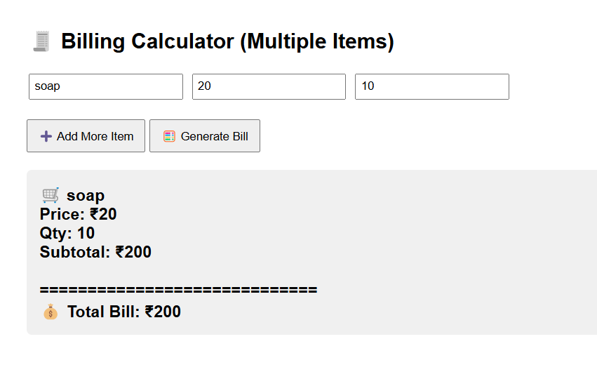

2.
<!DOCTYPE html>
<html>
<head>
<meta charset="UTF-8">
<title>User Registration</title>
</head>
<body>
<h2>User Registration</h2>

<form id="regForm">
<input type="text" id="name" placeholder="Enter Name"><br><br>
<input type="number" id="age" placeholder="Enter Age"><br><br>
<input type="text" id="email" placeholder="Enter Email"><br><br>
<button type="submit">Register</button>
</form>

<h3 id="message"></h3>

<script>
const form = document.getElementById("regForm");
const message = document.getElementById("message");

form.addEventListener("submit", e => {
e.preventDefault();

const user = {
name: document.getElementById("name").value,
age: document.getElementById("age").value,
email: document.getElementById("email").value
};

const { name, age, email } = user;

if (name.trim() === "") {
message.textContent = "Name cannot be empty.";
}
else if (age < 13 || age > 120) {
message.textContent = "Age must be between 13 and 120.";
}
else if (!/^[^\s@]+@[^\s@]+\.[^\s@]+$/.test(email)) {
message.textContent = "Invalid email format.";
}
else {
message.textContent = `Welcome, ${name} (Age: ${age}). Your email ${email} has been registered successfully!`;
}
});
</script>
</body>
</html>

